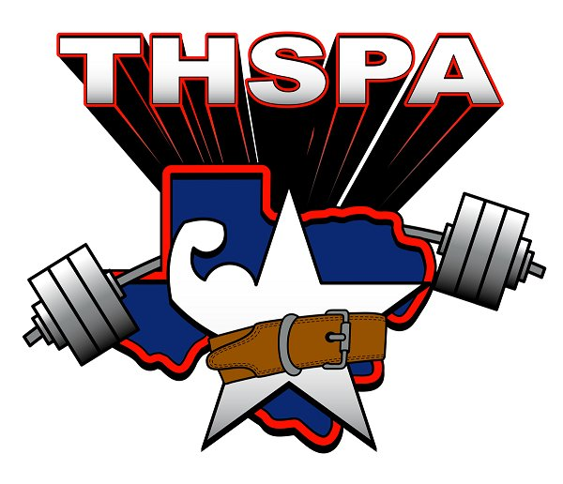
Coaches,
I hope that your season is going well and you are seeing your athletes reach the goals that they intended to meet. Attached is some important information that you need to know in preparation for the Regional and State meets.
Names- Check and make sure that all of your lifters names are correct on the website. If there are any errors or double listings due to misspellings let me know because this is how they will appear in the programs and on the lifter cards at the Regional and State meet.
Last Qualifying Date- February 25, 2017. All results from any qualifying meets should be sent in by midnight on the 25th. No results will be accepted after that time.
Weight Declaration- If you have any lifters who are qualified in more than one weight class, you must declare his weight class by 4:00 pm on Monday, February 27th. If you do not declare by this time, the lifter will be placed in the heavier weight class. Also, if you have any qualified lifters who are not going to compete at the Regional meet, let me know by 4:00 pm as well. You must contact me by email or cell phone. If you fail to remove a lifter, you will still be responsible for the $30.00 entry fee. The top 12 lifters in each weight class qualify for the Regional meet.
Regional Meet- Saturday, March 11th, WESLACO EAST HIGH SCHOOL - Gym
Entry Fee - $30.00 per lifter. Cash or checks only. Make all checks payable to:
WESLACO EAST POWERLIFTING
No Refunds will be given so make sure your entry fees are correct.
Early Weigh In- Friday, March 10th - 4:00- 5:30 pm at WESLACO EAST HIGH SCHOOL- Gym
Weigh In- Saturday, March 11th - 6:30 - 8:00 am at WESLACO EAST HIGH SCHOOL- Gym
PLEASE PARK VEHICLES IN THE EAST SIDE STUDENT PARKING LOT. SECURITY HAS BEEN INSTRUCTED TO ALLOW TEAMS TO ENTER NO EARLIER THAN 3:15 PM. WE WILL HAVE SIGNS POSTED AS TO WHERE WEIGH IN WILL TAKE PLACE.
At check in, please bring the following items.
- Entry Fees
- Drug Testing Form
- Eligibility Forms
- Meet Release Form
- Scholarship Application
March 11th:
Judges Meeting- 8:00 am
Coaches Meeting- 8:30 am
Lifting Begins- 8:45 am

- This will be a THREE platform meet. WE WILL FLIGHT IT. FLIGHT INFORMATION WILL BE AVAILABLE AT EARLY WEIGH INS AND ON DAY OF THE MEET.

- T- Shirts will be on sale at the meet.

- The address of the school is:
WESLACO EAST HIGH SCHOOL
810 S. PLEASANTVIEW DR.
WESLACO, TX 78596
If you have any other questions regarding the meet or accommodations, please do not hesitate to ask. Please share this information with your lifters and parents.
Thanks,
Rene Guzman THSPA Executive Director Region 5, Division I Weslaco East High School Email: aguzman@wisd.us
956-969-6950

