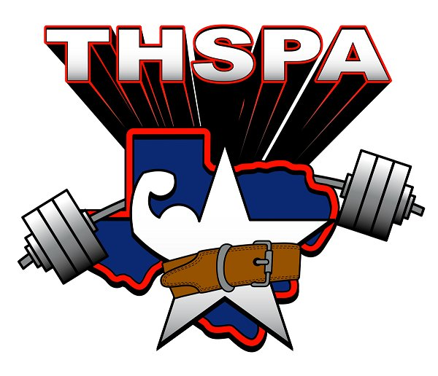
2014
Region V
Regional Meet Information

Last Qualifying Date- February 22, 2014. Remember that any meets during the last qualifying week must consist of at least 70 lifters from 7 different schools and you can only count 11 lifters from each school. All judges must also be certified. All results should be sent in by midnight on the 23rd. No results will be accepted after that time.
Weight Declaration- If you have any lifters who are qualified in more than one weight class, you must declare his weight class by 4:00 pm on Monday, February 24. If you do not declare by this time, the lifter will be placed in the heavier weight class. Also, if you have any qualified lifters who are not going to compete at the Regional meet, let me know by 4:00 pm as well. You must contact me by email or cell phone. If you fail to remove a lifter, you will still be responsible for the $30.00 entry fee. The top 10 lifters in each weight class qualify for the Regional meet.
Regional Meet- Saturday, March 8th at Weslaco, TX – The Weslaco East Field House
Entry Fee- $30.00 per lifter.
Cash or checks only. Purchase orders will not be accepted.
Make all checks payable to:
“WESLACO EAST POWERLIFTING”.
No Refunds will be given so make sure your entry fees are correct.
Early Weigh In- Friday, March 7th- 5:00- 6:30 pm at Weslaco East New Field House
Weigh In- Saturday, March 8th- 6:30- 8:00 am at Weslaco East Field New Field House
LIFTING WILL BEGIN 9:00 AM
At check in, please bring the following items.
- Entry Fees
- Eligibility Forms
- Meet Release Form
- Scholarship Applications

CONCESSION STAND: There will be a concession stand selling drinks, candy, nachos and other items as well.

ENTRY FEE FOR GENERAL PUBLIC: $5.00 for Adults/ $3.00 for Students

REGIONAL MEET SHIRTS: Meet shirts will be $15.00 per shirt.

HOSPITALILTY ROOM: There will be a hospitality room that will have breakfast and lunch for all coaches and judges. There will be bbq chicken plates with fixings and drinks.

TRAINERS: The Weslaco East Trainers will be on site during the course of the meet.

****Also, a Dairy Queen representative will be on site to take your team order for meals and will deliver to Weslaco East gym.****

