Registration Tab

1.Enter New Meet, Date, Region information:
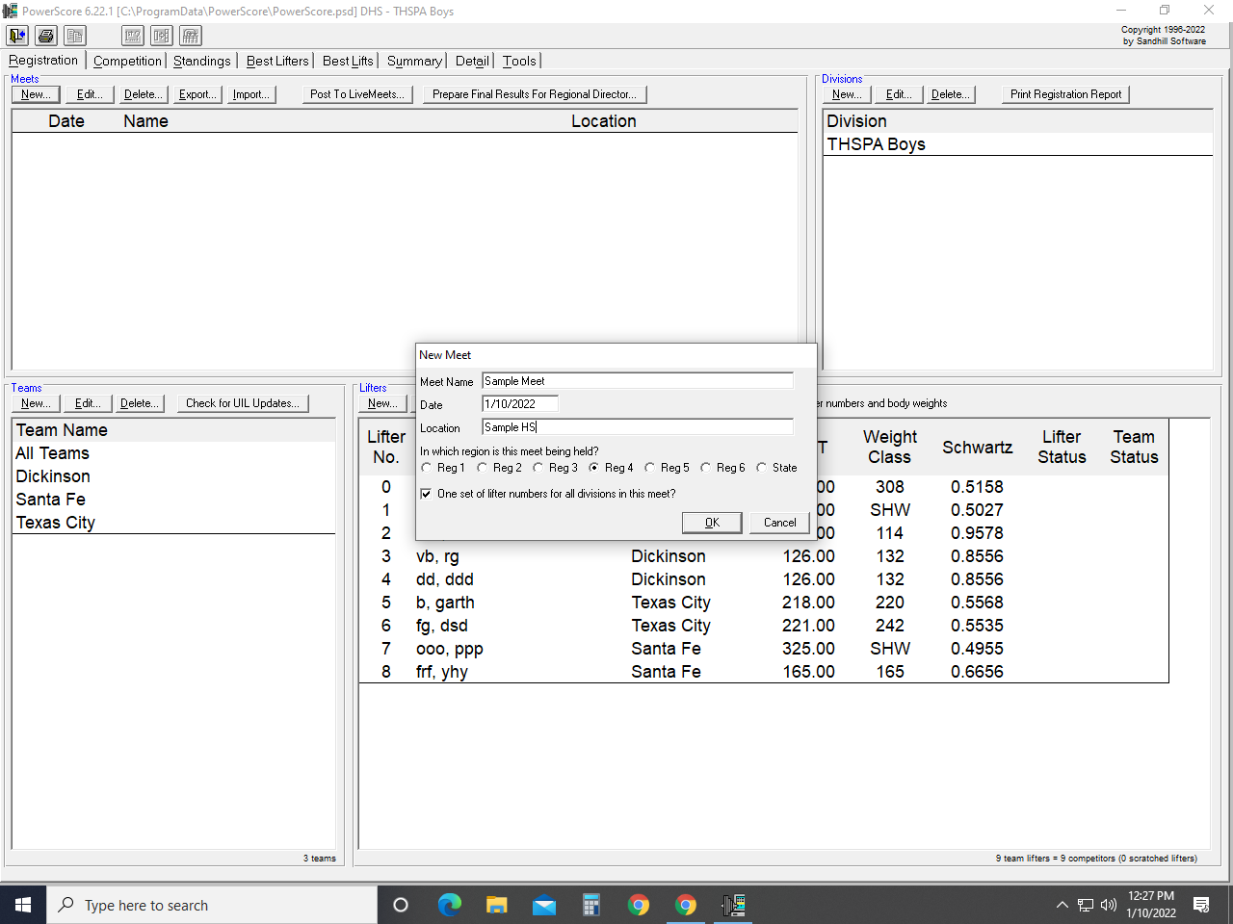

2. Enter Division:
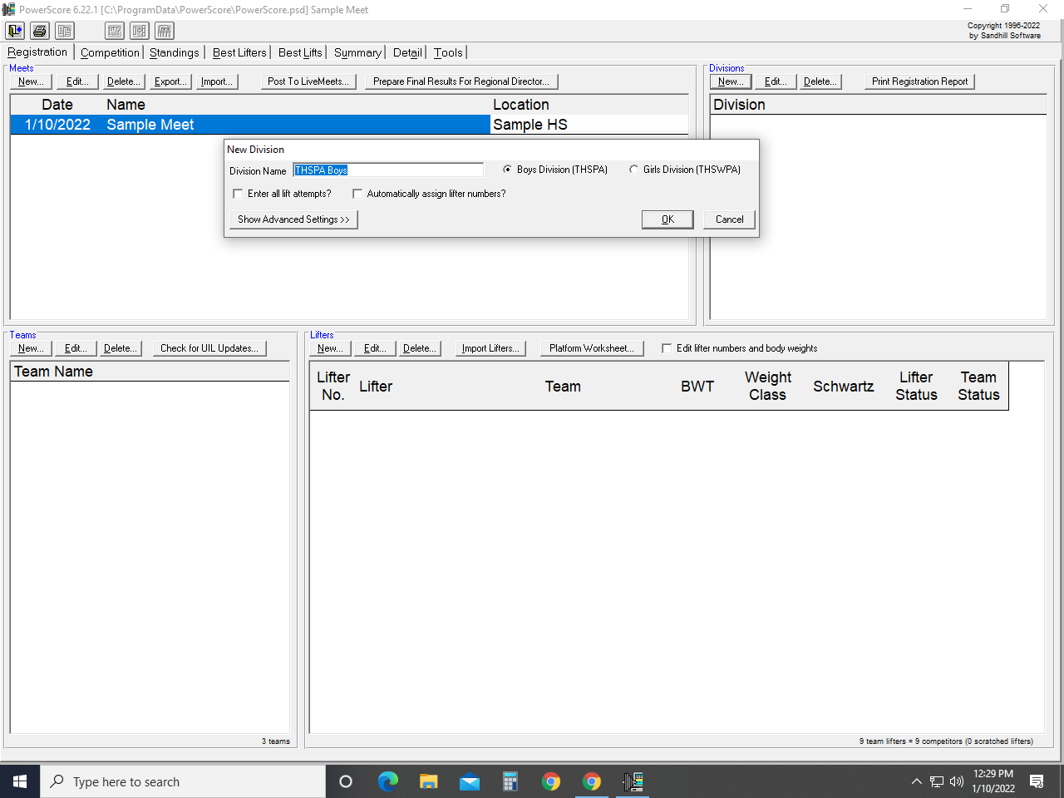

3. Add 308 Class by clicking “Show Advanced Setting” button:
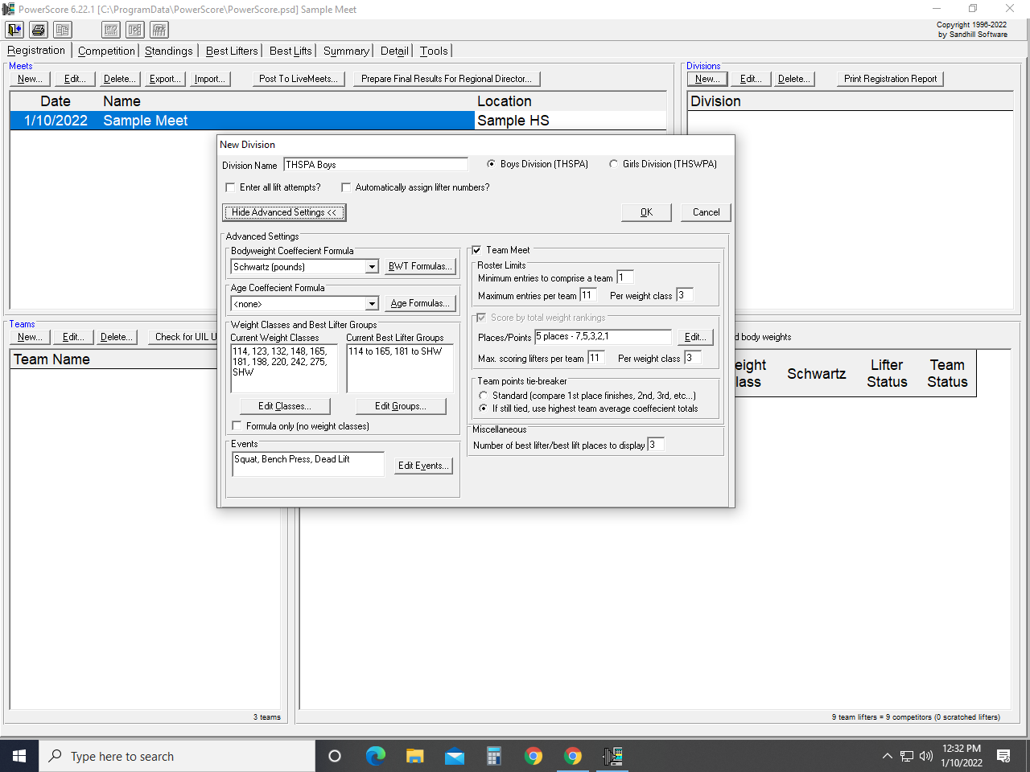

Edit the Current Weight Classes by adding 308
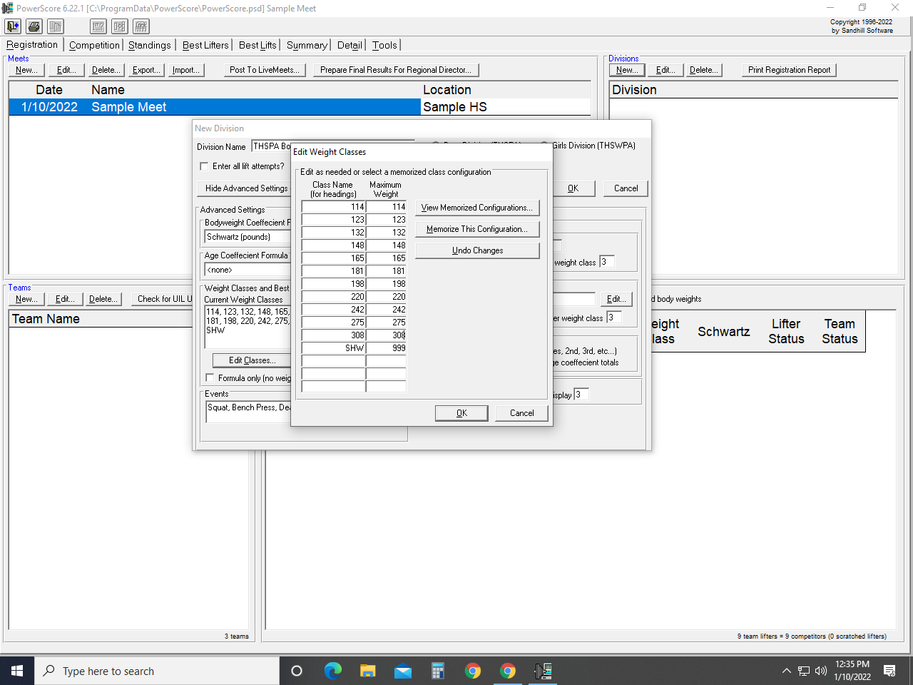

Edit the Current Best Lifter Groups:
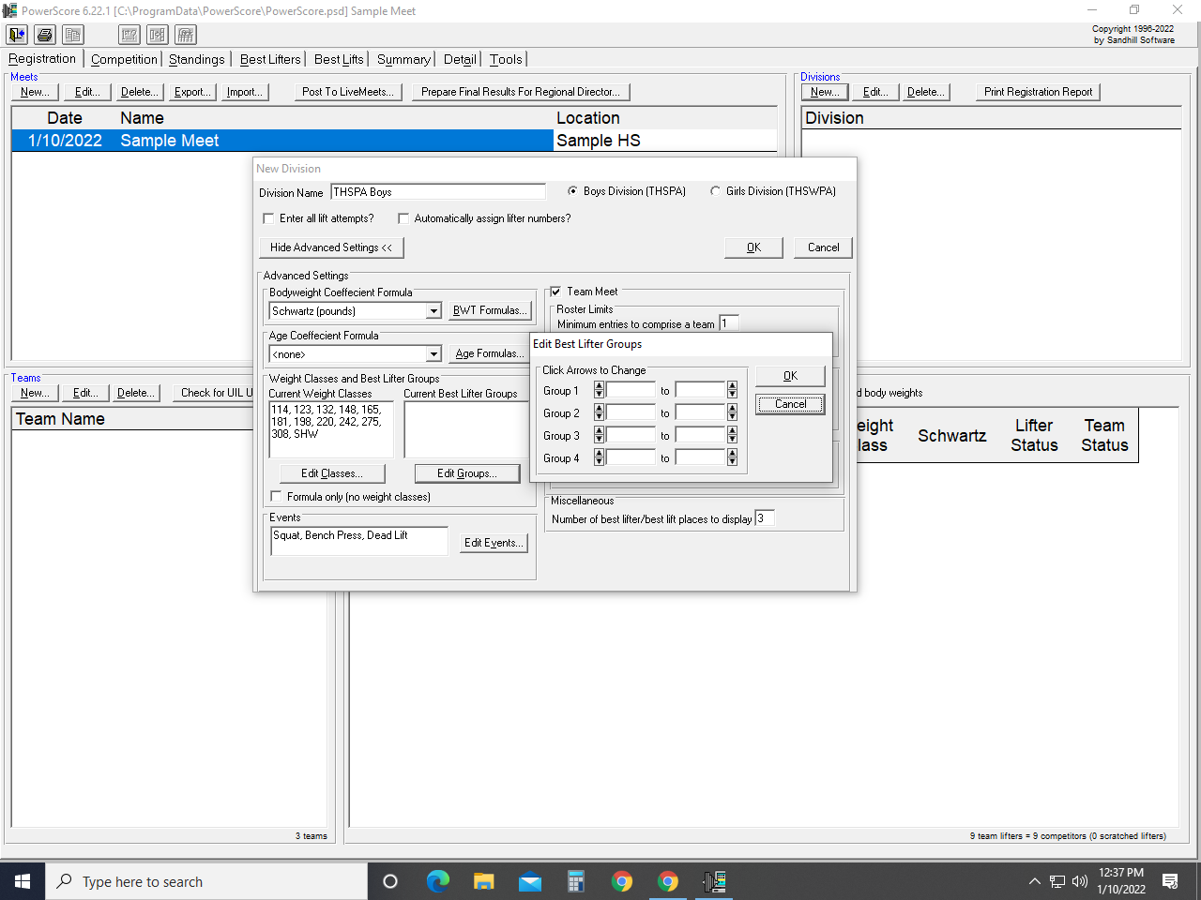

Group 1: 114 to 181
Group 2: 198 to SHW
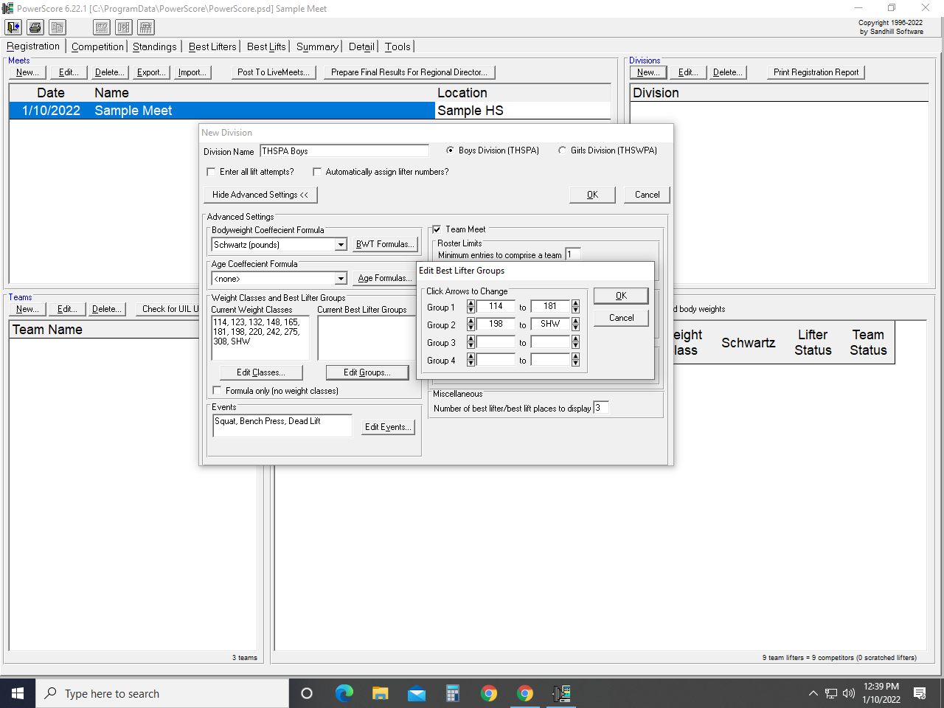

Adjust Maximum Entries Per Team & Max Scoring Lifters Per Team:
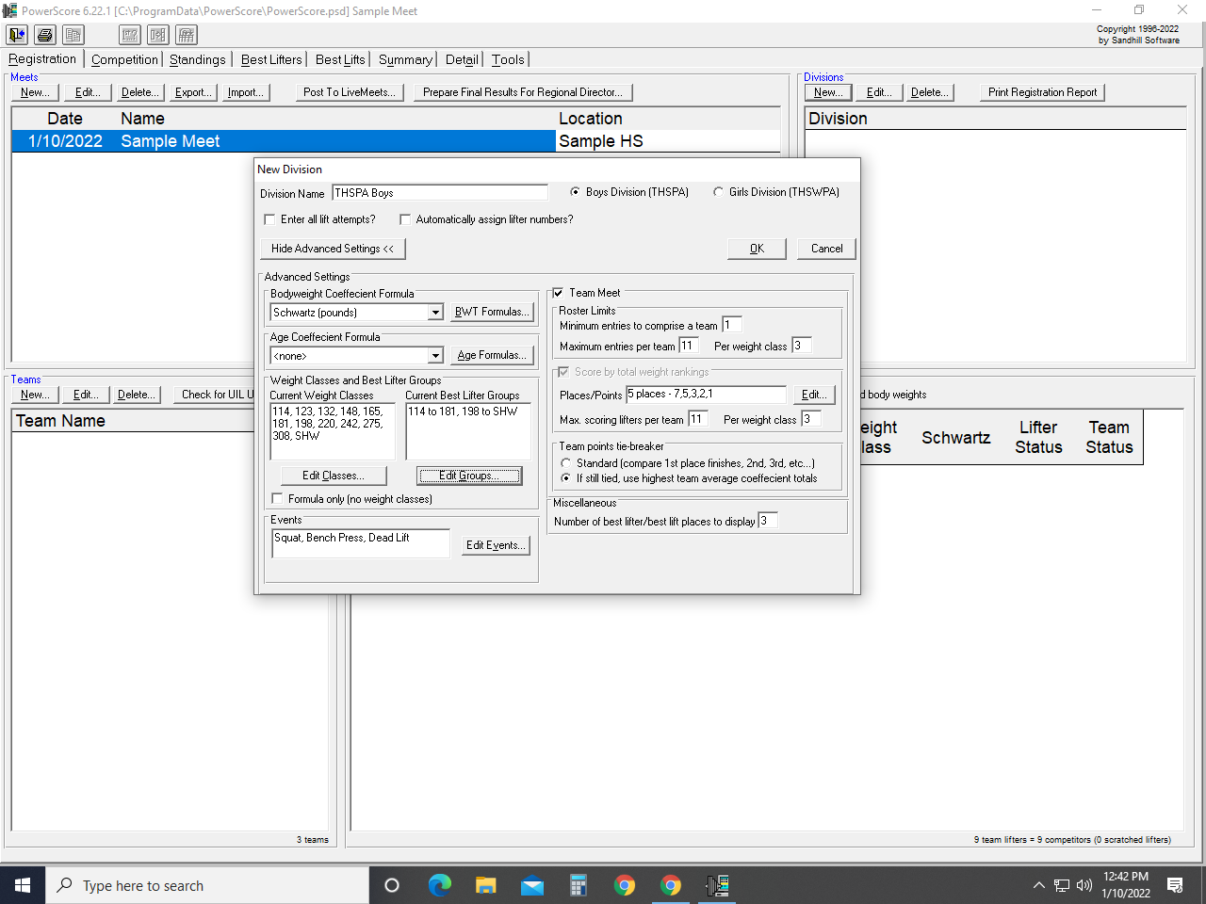

Change 11 to 12
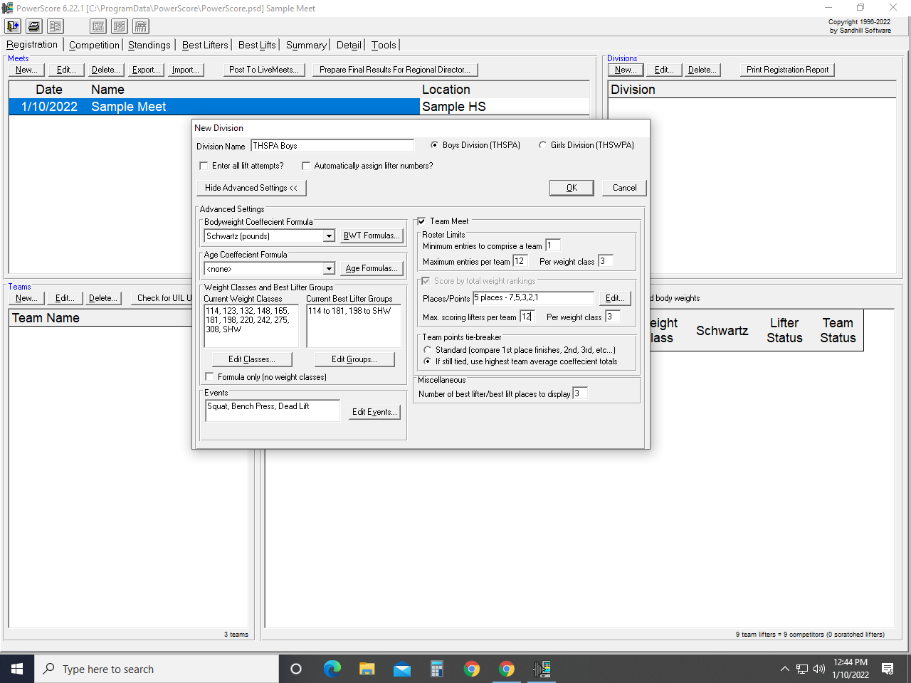

Click “OK” button

4. Enter all Team Names for competing schools:
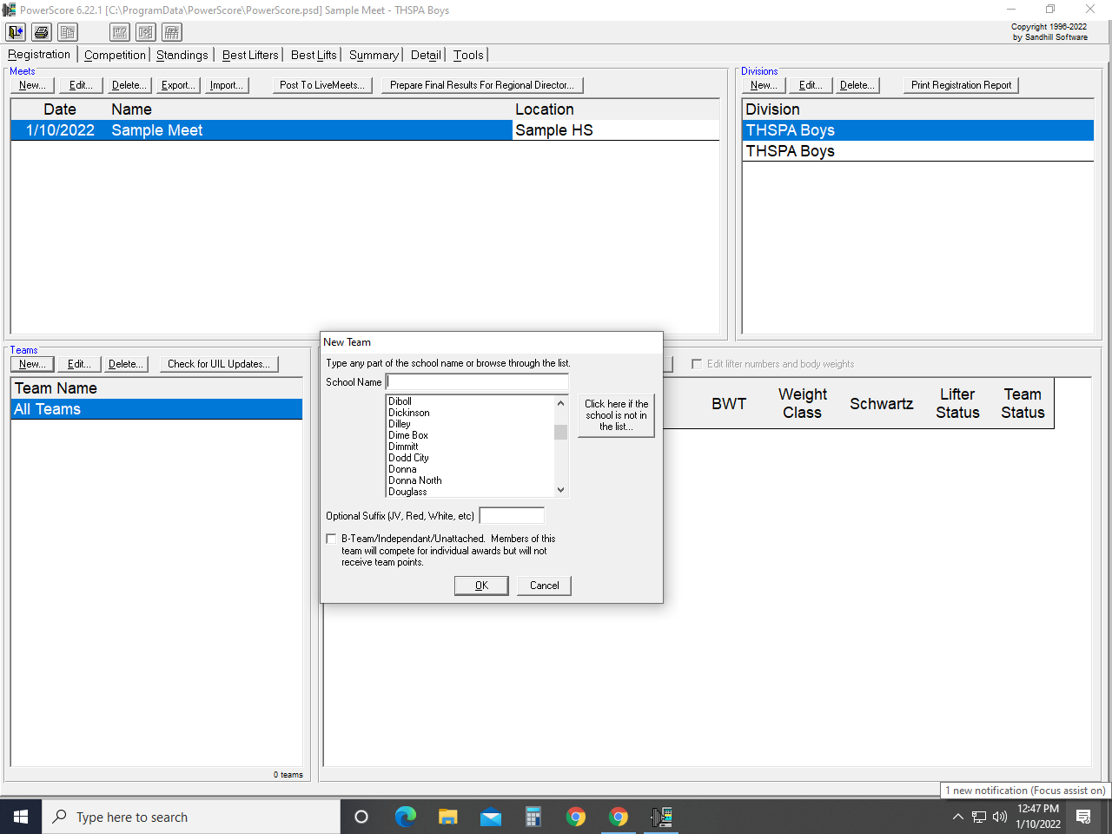

5. Enter all Lifters’ information:
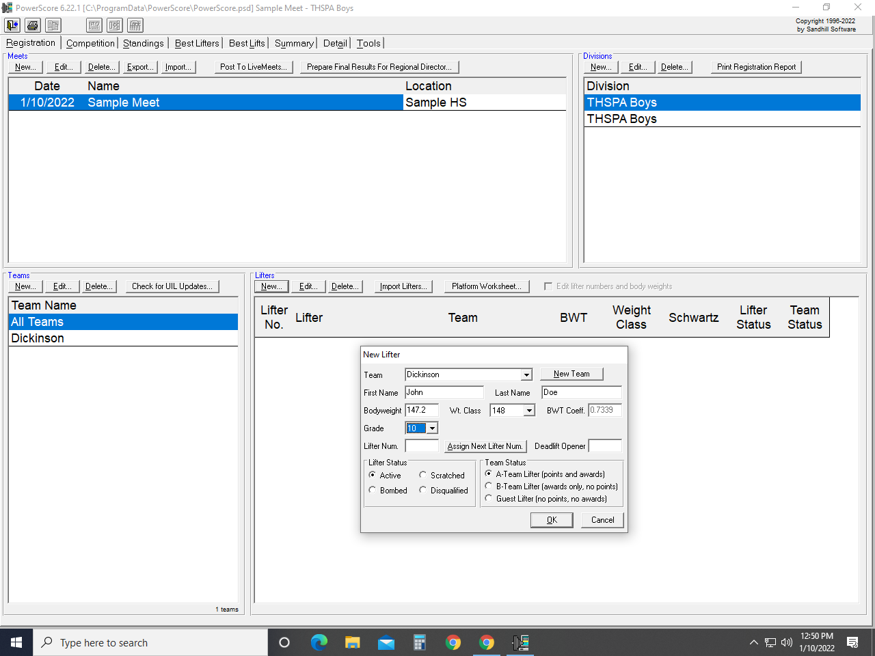

Competition Tab

6. Enter Lifters’ Lifts:
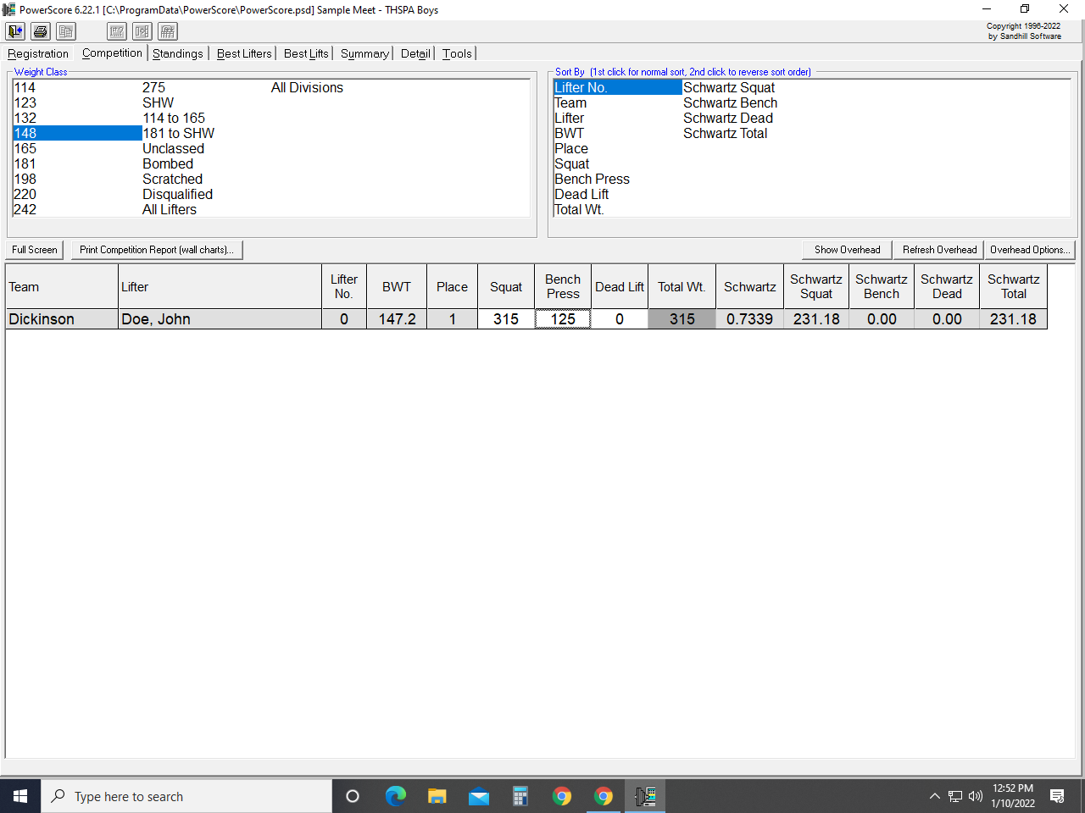
7. Tabs: Standing, Best Lifters, Summary, Detail are self explanatory

Registration Tab

8. Sending Meet Results to Director:
Click “Prepare Final Results For Regional Director” button
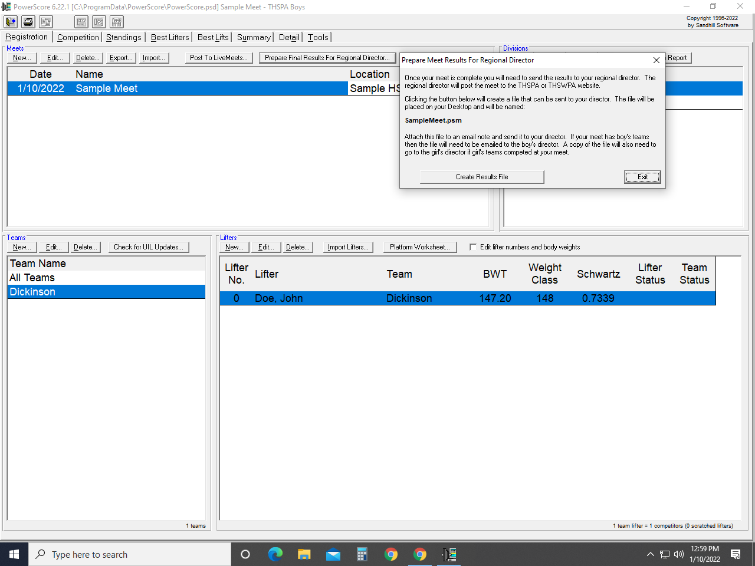

Click “Create Results File” button
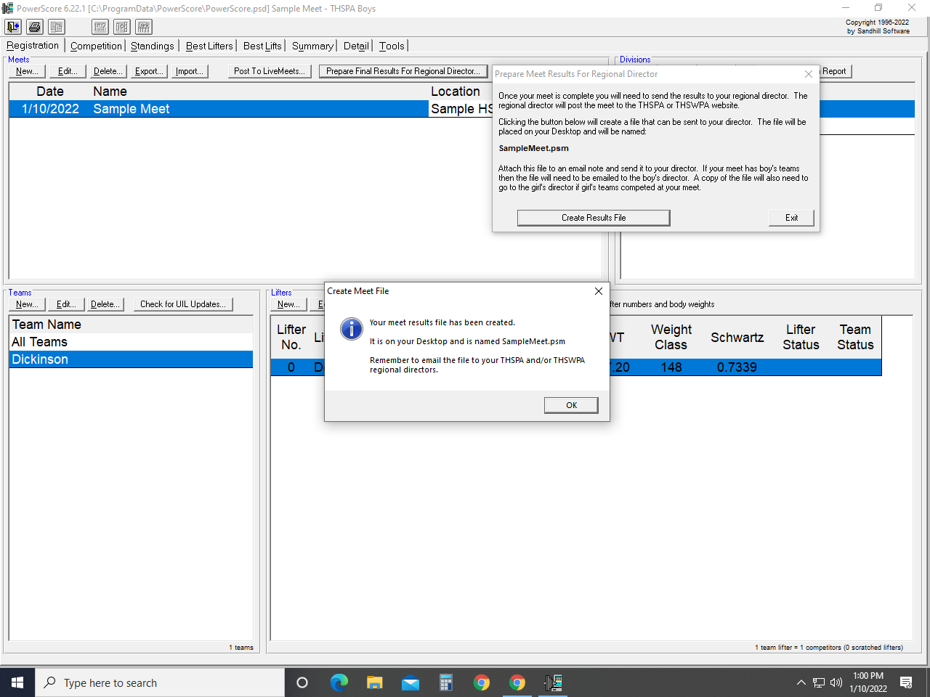

A PSM. File will be placed on your Desktop Screen

Email your Regional Director with the PSM. File attachment.

