The Region 3 Division 2 Regional Meet will be on
March 5, 2015 at Eagle Coliseum in Rusk, TX.
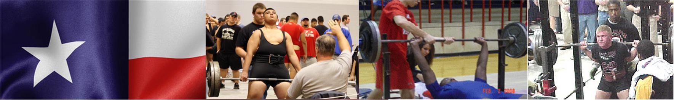

- Lifting
    - Begins at 3:30 PM.
- Platforms
    - There will be 4 platforms, and no flights.
Platform 1 | Platform 2 | Platform 3
114, 123,132 | 148,165,181 | 198,220,242
Platform 4
275,SHW

- Bring with you:
    - Eligibility Form - Signed by your Principal or Superintendent
    - Scholarship Application (Optional) For senior lifters who would like to be considered for a $1,000 scholarship to help with college expenses.
    - Check for $30.00 per lifter payable to: Rusk Athletics*
*Your school becomes responsible for your lifter(s) entry fee at 4:00 p.m., Monday, March 2. Please notify me on or before the deadline if your lifters can’t compete or you will be responsible for their entry fee.

*No payment is necessary for alternates.

PLEASE have SEPARATE CHECKS for meals and entry fees.

- Alternates
    - If you have lifters ranked in the top 20, bring them with you as there may be no-shows or lifters who do not make weight.
- Weigh In
    - Wednesday early weigh in: 5:00 to 6:30 P.M.
    - Thursday afternoon weigh in: 1:30 to 3:00 PM.
- Coaches / Judges Meeting
    - 3:00 to 3:30 in the weight room in the Coliseum.
- Admission
    - $5.00
- T-shirts
    - $15.00
- Supper
    - There will be a supper served for the coaches.
    - Meals for the athletes: The cost will be $6.00 each. Make checks for athlete’s lunches payable to Rusk Athletic Boosters. There will also be a concession stand.
- Restaurant Links
    - In Rusk
    - In Jacksonville
    - In Tyler
- Lodging
    - If you plan on staying in a hotel the night before the meet, there are a few hotels in Rusk and Jacksonville. However, you may have to stay in Tyler, Lufkin or Palestine. Plan on a 45 minute drive from those places.
Weston Inn & Suites  590 North Dickinson Dr.  Rusk, TX 75785  Off of Hwy 69 | Phone: 903-683-8383
Comfort Inn  1848 South Jackson Street  Jacksonville, TX 75766 | Phone: (903) 589-8500
La Quinta Inn & Suites  1902 S. Jackson Street  Jacksonville, TX 75766  Off of Hwy 69 S. in Jacksonville, TX | Phone: 1-903-586-6504
Best Western Executive Inn  1659 S Jackson Street  Jacksonville, Texas, 75766-3027  Off of Hwy 69 S. in Jacksonville, TX | Phone: 903-586-0007  Fax: 903-586-0010
Holiday Inn Express Jacksonville  1923 S Jackson St  Jacksonville, TX 75766  Off of Hwy 69 in Jacksonville, TX | Phone: (888) 465-4329  903-589-8900

