The Region 3 Division 2 Regional Meet will be on
March 9, 2017 at Malakoff HS, Malakoff TX.
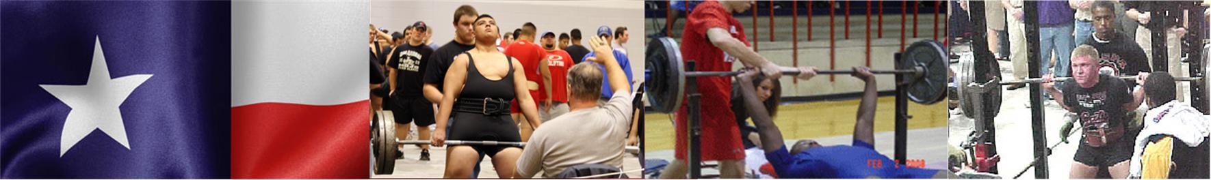

- Lifting
    - Begins at 4:00 PM.
- Platforms
    - There will be 4 platforms, and no flights.
Platform 1 | Platform 2 | Platform 3
114, 123,132 | 148,165,181 | 198,220,242
Platform 4
275,SHW

- Bring with you:
    - Eligibility Form - Signed by your Principal or Superintendent
    - Scholarship Application (Optional) For senior lifters who would like to be considered for a $1,000 scholarship to help with college expenses.
    - Check for $30.00 per lifter payable to: Malakoff Athletics*
*Your school becomes responsible for your lifter(s) entry fee at 4:00 p.m., Monday, Feb 27th. Please notify me on or before the deadline if your lifters can’t compete or you will be responsible for their entry fee.

*No payment is necessary for alternates.

- Alternates
    - If you have lifters ranked in the top 20, bring them with you as there may be no-shows or lifters who do not make weight.
- Weigh In
    - Wednesday early weigh in: 5:00 to 6:30 P.M.
    - Thursday afternoon weigh in: 1:30 to 3:00 PM.
- Coaches / Judges Meeting
    - 3:30
- Admission
    - $5.00
- T-shirts
    - Meet shirts will be available
- Supper
    - There will be a supper served for the coaches.
    - Meals for the athletes: The cost will be $6.00 each. Make checks for athlete’s lunches payable to Malakoff Athletic Boosters. There will also be a concession stand.

