The Region 3 Division 1 Regional Meet will be on
Wednesday March 4, 2020 at Pine Tree Pirate Center, Longview, Tx.

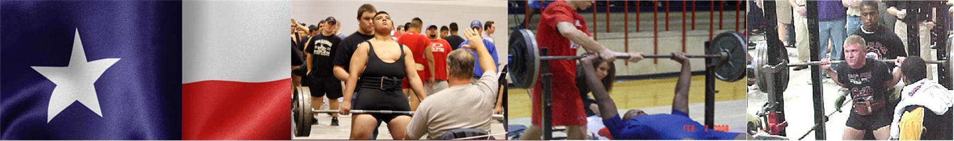

- Lifting
    - Begins as close 4:00 PM as possible depending on when judges can make it.

- Platforms
  - There will be 5 platforms.

- Bring with you:
    - Eligibility Form - Signed by your Principal or Superintendent
    - Scholarship Application (Optional) For senior lifters who would like to be considered for a $1,000 scholarship to help with college expenses.
    - Check for $35.00 per lifter payable to: Whitehouse Athletics-Powerlifting
*Your school becomes responsible for your lifter(s) entry fee at 4:00 p.m., Monday, Mar 2nd. Please notify me on or before the deadline if your lifters can’t compete or you will be responsible for their entry fee.

*No payment is necessary for alternates.

- Alternates
    - If you have lifters ranked in the top 20, bring them with you as there may be no-shows or lifters who do not make weight.
- Weigh In
    - Tuesday early weigh in: 5:00 to 6:30 P.M.
    - Wednesday afternoon weigh in: 2:00 to 3:30 P.M.

- Coaches / Judges Meeting
    - 3:30
- Admission
  - There will be admission charged at the door.
- T-shirts
    - Meet shirts will be available
- Supper
    - There will be a supper served for the coaches.
    - Meals for the athletes: The cost will be $6.00 each. Make checks for athlete’s lunches payable to Pine Tree Athletics. There will also be a concession stand.

