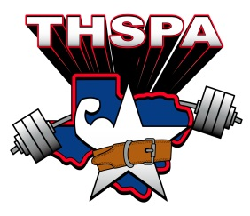

ACADEMIC ALL STATE 2016
FIRST TEAM
Athlete | School
Tyler Vasut | East Bernard ISD
Kristopher Imhof | San Antonio Cole
Fernando Maldonado | Smithville High School
Luis A. Gonzalez | Alice HighSchool
Tanner Duke | Atlanta
Ray Navarro | Natalia
Duston Vargas | Andrews High School
Jeremiah Robertson | Huntington High School
Rigo Ayala | Edcouch-Elsa
Jet Grant | Sundown High School
Jeremy Rodriguez | Geronimo Navarro
CalebThomas | Snyder High School
Jared Holmes | Perrin High
Michael Lopez | Levelland
Austin Moore | Orangefield
Collin Partridge | Wichita Falls Rider
Eric Vela | Muleshoe High School
Taylor Morin | Forsan High School
Nathan Zambrana | Southwest High School
Ryan Slagle | Pottsboro High School

